Manage first aid services and resources

This course gives you the skills to perform risk assessments and determine your first aid needs in line with workplace health and safety legislations, and the first aid codes of practice. It also teaches you how to design and run first aid facilities (such as sick rooms) and implement and monitor incident responses in your workplace.
This course should be completed by anyone who is responsible for coordinating first aiders or managing a first aid facility such as a sick room.
St John offers the following delivery options:
- 4-hour face to face workshop: This is full face to face course and participants are required to attend the full session.
- Assessment only: This course is for those who are confident in their skills and only want to complete the assessment.
CERTIFICATE
On successful completion of this course you will be issued a statement of attainment in:
- HLTAID016 Manage first aid services and resources
COURSE OUTLINE
This course covers the following:
- Determine workplace first aid requirements  - Risk assessment and management  - Planning a first aid response  - Designing and managing first aid facilities | - Managing first aid equipment and resources  - Management of first aid documentation  - Designing incident response plans  - WHS first aid legislation and codes of practice
ASSESSMENT METHODS
A successful outcome for this statement of attainment will be determined by a range of different methods including written assessment, observation of simulated and practical activities etc.
LOCATIONS
St John delivers first aid courses nationally and across many locations in Australia. Choose the location to suit your needs.
- PUBLIC (at a venue near you)
- CUSTOMISED (on-site consultation)
- ONSITE (at a venue of your choice)
- ONLINE (training delivered online from our e-Learning platform)

DELIVERY BY ST JOHN’S RTO PARTNERS
St John Ambulance Australia’s courses are delivered by way of partnership agreements (e.g. with State or Territory St John Ambulance organisations). Our partners are authorised to deliver training on behalf of St John Ambulance Australia Ltd. (TOID 88041). Contact details for our partner organisations are available from www.stjohn.org.au or call 1300 ST JOHN.
PARTICIPANT’S HANDBOOK
Download the Participant’s Handbook from www.stjohn.org.au for more information about completing a course with St John Ambulance Australia. This includes information about complaints, appeals and privacy information.
We actively tailor training to meet the needs of people from diverse backgrounds and abilities and encourage all to apply.
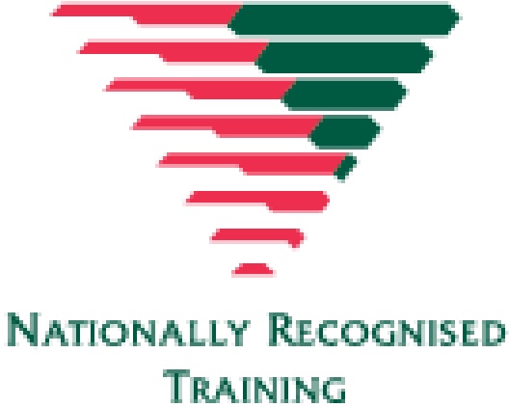
For more information on this course,
contact the Training Office in your area
1300 ST JOHN (1300 785 646) WWW.STJOHN.ORG.AU

