Occupational first aid

Do you work with heavy machinery or in a high-risk work environment? A higher first aid qualification may be required to ensure your staff and employees are protected against potential dangers.
This course equips students for emergencies in a high-risk work environment and provides the skills necessary to be responsible for a first aid room.
PRE-REQUISITE UNIT
Participants are required to undertake or present evidence for HLTAID011 Provide First Aid prior to commencing HLTAID015 Provide advanced resuscitation and oxygen therapy.
COURSE DURATION
St John offers the following options:
- 4.5 days face to face workshop: This is full face to face course and participants are required to attend all 4 days. Those participants who have completed HLTAID011 Provide First Aid in last three (3) years may be entitled to an exemption from the first two days.
- 2.5 days (face to face workshops with pre-work): Participants are required to undertake online e-learning module prior to attending the face to face workshops for practice and assessment.
- Assessment only: This course is for those who are confident in their skills and only want to complete the assessment.
CERTIFICATE
On successful completion of this course you will be issued a statement of attainment in:
- HLTAID009 Provide cardiopulmonary resuscitation
- HLTAID010 Provide basic emergency life support
- HLTAID011 Provide First Aid
- HLTAID014 Provide Advanced First Aid
- HLTAID015 Provide advanced resuscitation and oxygen therapy
- HLTAID016 Manage first aid services and resources
St John recommends, as per the First Aid in the Workplace Code of Practice and the Australian Resuscitation Council guidelines, that first aid skills are renewed every 3 years and resuscitation skills (HLTAID009/HLTAID0015) are renewed every 12 months.

COURSE OUTLINE
This course covers the following:
- Resuscitation including using a soft bag resuscitator  - Oxygen therapy and application of an AED, including equipment maintenance  - Clinical assessment in detail  - Basic anatomy of all body systems  - Triage  - Risk assessment  - Managing all aspects of a First Aid Room  - Documentation | - Management of: Eye injuries, lifting and moving of a casualty, head, neck and spinal injuries including collars and spine board  - Casualties who are emotionally disturbed and under the inﬂuence of drugs and alcohol  - Post incident management  - First aid in the context of the workplace  - Relevant First Aid legislation  - Planning a response to a major incident  - Evaluating provision of First Aid
ASSESSMENT METHODS
A successful outcome for this statement of attainment will be determined by a range of different methods including written assessment, observation of simulated and practical activities etc.
You will be required to demonstrate CPR on a manikin on the floor.
LOCATIONS
St John delivers first aid courses nationally and across many locations in Australia. Choose the location to suit your needs.
- PUBLIC (at a venue near you)
- CUSTOMISED (on-site consultation)
- ONSITE (at a venue of your choice)
- ONLINE (training delivered online from our e-Learning platform)
DELIVERY BY ST JOHN’S RTO PARTNERS
St John Ambulance Australia’s courses are delivered by way of partnership agreements (e.g. with State or Territory St John Ambulance organisations). Our partners are authorised to deliver training on behalf of St John Ambulance Australia Ltd. (TOID 88041). Contact details for our partner organisations are available from www.stjohn.org.au or call 1300 ST JOHN.
PARTICIPANT’S HANDBOOK
Download the Participant’s Handbook from www.stjohn.org.au for more information about completing a course with St John Ambulance Australia. This includes information about complaints, appeals and privacy information.
We actively tailor training to meet the needs of people from diverse backgrounds and abilities and encourage all to apply.
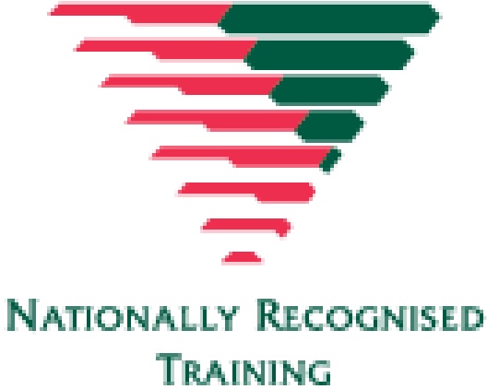
For more information on this course,
contact the Training Office in your area
1300 ST JOHN (1300 785 646) WWW.STJOHN.ORG.AU

