Provide Advanced First Aid

This course is appropriate for people who work in high risk areas, act as first aiders for larger facilities or groups, or work in areas where help may be delayed or have difficulty accessing casualties.
The course covers a broad range of advanced skills and provides you with high-level capabilities for managing large incidents, major trauma, sudden cardiac arrest and emotionally disturbed and drug affected casualties.
COURSE DURATION
St John offers the following delivery options:
- 4 days face to face workshop: This is full face to face course and participants are required to attend all 4 days. Those participants who have completed HLTAID011 Provide First Aid in last three (3) years may be entitled to an exemption from the first two days.
- 2 days (face to face workshop with pre-work): Participants are required to undertake online e-learning module prior to attending the face to face workshops for practice and assessment.
- Assessment only: This course is for those who are confident in their skills and only want to complete the assessment.
CERTIFICATE
On successful completion of this course you will be issued a statement of attainment in:
- HLTAID009 Provide cardiopulmonary resuscitation
- HLTAID010 Provide basic emergency life support
- HLTAID011 Provide First Aid
- HLTAID014 Provide Advanced First Aid
St John recommends, as per the First Aid in the Workplace Code of Practice and the Australian Resuscitation Council guidelines, that first aid skills are renewed every 3 years and resuscitation skills (HLTAID009) are renewed every 12 months.
COURSE OUTLINE
This course covers:
- Major trauma management  - Triage  - Use of spine boards and stretchers  - Managing emotionally disturbed casualties  - Pulse, blood pressure and pupil reactions  - Medications  - Clinical assessments  - Pain management | - Body systems Drug and alcohol affected casualties  - DRSABCD action plan  - Infection control  - Automated external defibrillation (AED)  - Soft bag resuscitation  - Post incident stress management

ASSESSMENT METHODS
A successful outcome for this statement of attainment will be determined by a range of different methods including written assessment, observation of simulated and practical activities etc.
You will be required to demonstrate CPR on a manikin on the floor.
LOCATIONS
St John delivers first aid courses nationally and across many locations in Australia. Choose the location to suit your needs.
- PUBLIC (at a venue near you)
- CUSTOMISED (on-site consultation)
- ONSITE (at a venue of your choice)
- ONLINE (training delivered online from our e-Learning platform)
DELIVERY BY ST JOHN’S RTO PARTNERS
St John Ambulance Australia’s courses are delivered by way of partnership agreements (e.g. with State or Territory St John Ambulance organisations). Our partners are authorised to deliver training on behalf of St John Ambulance Australia Ltd. (TOID 88041). Contact details for our partner organisations are available from www.stjohn.org.au or call 1300 ST JOHN.
PARTICIPANT’S HANDBOOK
Download the Participant’s Handbook from www.stjohn.org.au for more information about completing a course with St John Ambulance Australia. This includes information about complaints, appeals and privacy information.
We actively tailor training to meet the needs of people from diverse backgrounds and abilities and encourage all to apply.
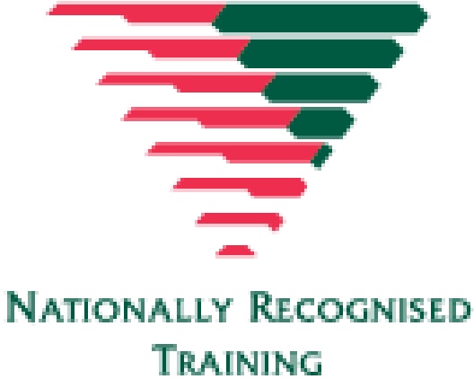
For more information on this course,
contact the Training Office in your area
1300 ST JOHN (1300 785 646) WWW.STJOHN.ORG.AU

